Bradenstoke Solar Farm Community Benefit Fund.
Annual General Meeting
1st November 2023 – 6:00pm
Chairman’s report

Chair’s Report November 2023

Welcome to our 2023 AGM.

Firstly, thank you to Mary Hardwidge of Community First for her patient handling of the grant requests and payments. Our slimmed down sign off for payments that have been previously agreed is working well. We now need to focus on getting some more “before and after” photographs to embellish the website!

We have only approved 6 applications this year. Whilst they will undoubtedly make a difference to the communities in receipt of these grants, there is money in the bank account which could be making a much bigger difference.

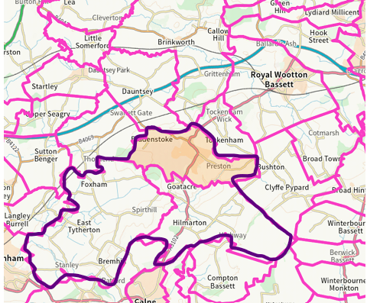
Looking at the current catchment area, which is any PARISH which shares the perimeter fence of MoD Lyneham, this is very geographically distorted.
There are parishes much closer (Tockenham, Clyffe Pypard, Dauntsey, Brinkworth) which could also benefit if we were to change the boundaries.

Food for thought.

I look forward to another year of investing in our communities.
Allison Bucknell
Chair of the BSPCBF

